Team ID: PNT2022TMID13652

Create A Database In Cloudant DB

Aim: To create a database in Cloudant DB to store location data.

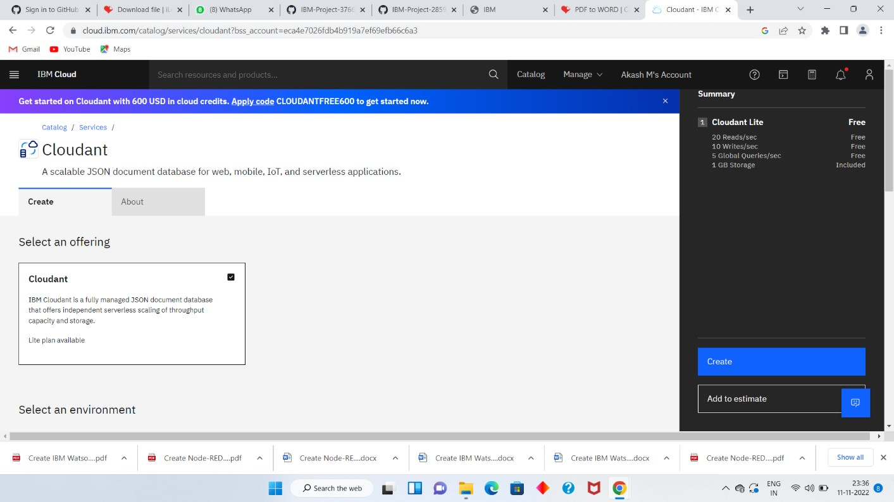

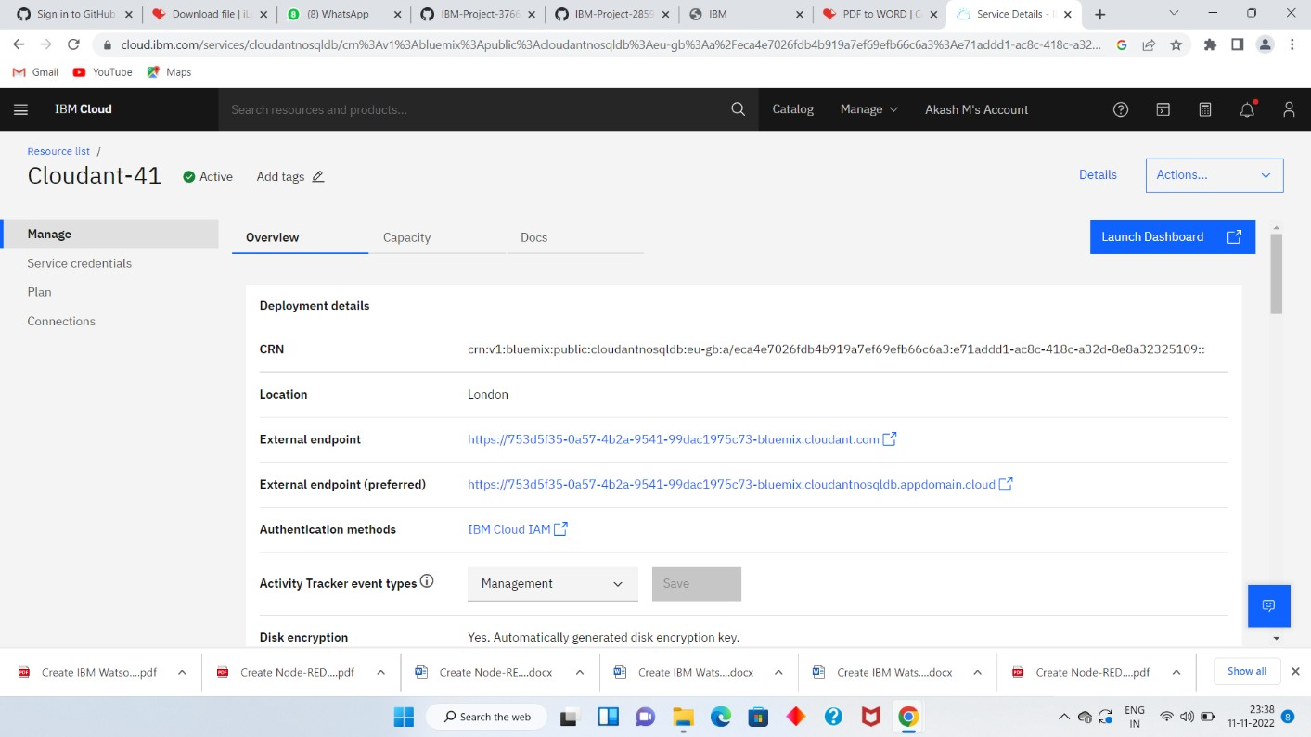

* The Cloudant database resource was created successfully
* Clicked on Launch Dashboard

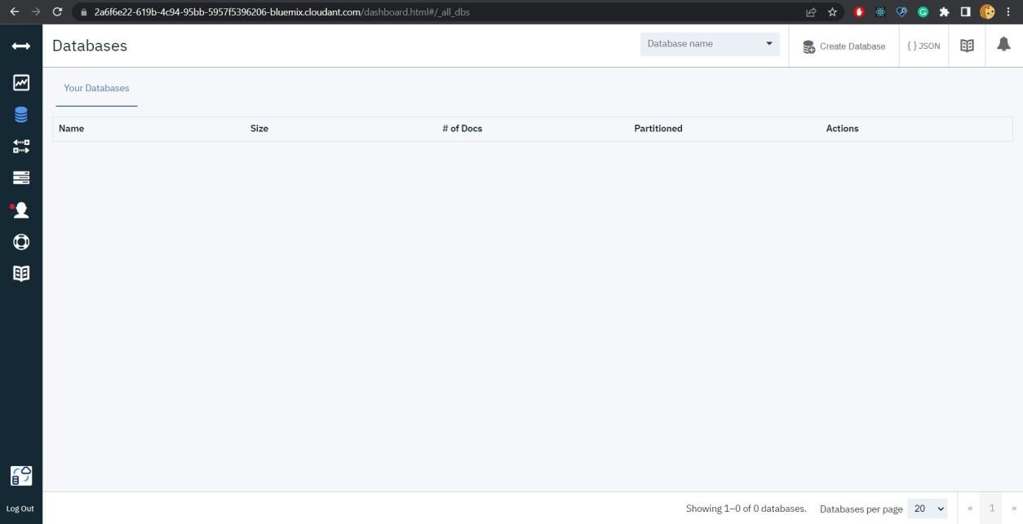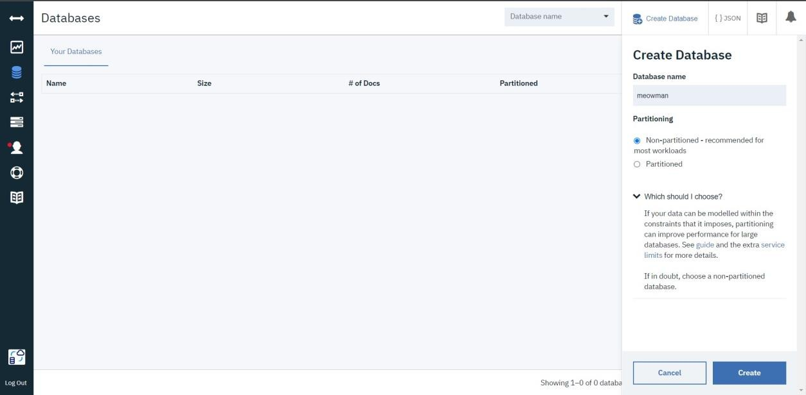

* Clicked on “Create Database”. Entered “Meowman” as the database name and the “Non-partitioned” option
* The database “Meowman” was created successfully

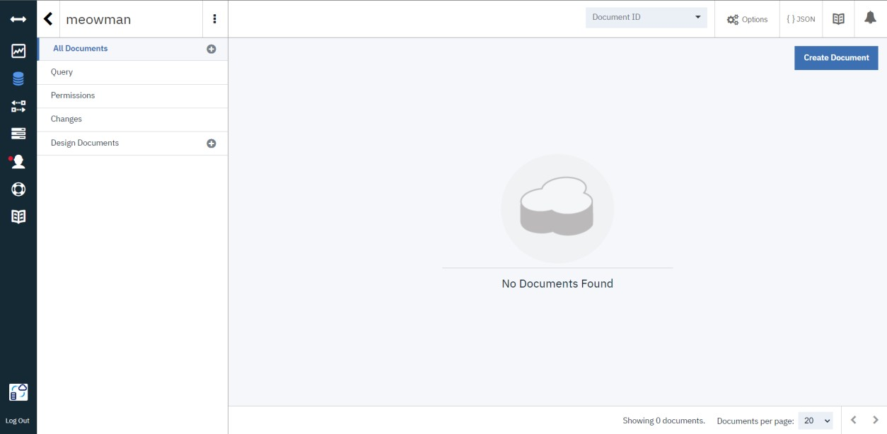

Result:

A database to store the location data was created successfully on Cloudant DB